ChaTGPT – A Comprehensive STUDY on GPT model and Impact ON Different fields

University of Calcutta

RAHUL BISWAS

MSc. Computer Science Semester 3

**Table of Contents**

|  |  |
| --- | --- |
| Contents | Page No. |
| Abstract………………………………………………………………………… | 02 |
| Introduction……………………………………………………………………. | 03 |
| Pre-requisite……………………………………………………………………. | 05 |
| Transformer Architecture……………………………………………………… | 07 |
| Generate Pre-Trained Transformer ……………………………………………. | 12 |
| Impact on different fields ………………………………………………………. | 16 |
| Conclusion……………………………………………………………………... | 20 |

**Abstract**

Generative Pre-trained Transformer (GPT) model, developed by OpenAI, shows a remarkable performance in the field of Natural Language Processing (NLP), which accelerated our works for developing a machine that can communicate with humans as humanly possible. GPT is based on transformer architecture, which is solely based on attention mechanism, eliminating recurrence and convolution completely. It also shows remarkable performance with respect with Recurrent Neural Networks as it computes in parallelism. GPT gains popularity due to these characteristics in domains like research, industrial works. In this review, we try to understand GPT model, potential applications for the GPT model and its future in the various domain.

**Introduction**

A language can be defined as a system of rules or symbols that are combined to communicate or transmit information. Given that not all users are proficient in machine-specific languages, Natural Language Processing (NLP) serves those individuals who lack the time to acquire new languages or achieve mastery in them. [1]. NLP has revolutionized communication, facilitating more natural interactions between humans and robots. The advancement of NLP has been driven by the rapid increase of textual material on the internet. Recent breakthroughs have facilitated new strategies to address these difficulties. A significant advancement in NLP is the creation of GPT. [2]. GPT became famous after the launch of ChatGPT by OpenAI, a research company [3] that emphasizes the advancement of AI technologies. GPT is a deep learning model pre-trained on extensive text corpora that may be fine-tuned for specific applications such as language production, sentiment analysis, language modeling, machine translation, and text categorization. [4].

The transformer architecture employed in GPT represents a substantial improvement over earlier methodologies in natural language processing, including RNN and CNN. It employs a self-attention method that enables the model to take into account the context of the entire phrase while producing the subsequent word, hence enhancing the model's capacity to comprehend and generate language. The decoder generates output text from the input representation. The objective of minimizing sequential computation underpins the Extended Neural GPU, ByteNet, and ConvS2S, all of which utilize convolutional neural networks as fundamental components, processing hidden representations in parallel across all input and output positions. In these models, the operational requirements to correlate signals from two random input or output locations increase with the distance between them, following a linear pattern for ConvS2S and a logarithmic one for ByteNet. This complicates the acquisition of interdependence between remote sites.[5]

GPT is capable of executing a diverse array of tasks in natural language processing. A primary strength lies in natural language understanding (NLU), enabling the analysis and comprehension of text, including the identification of entities and relationships within phrases. It is also adept at natural language generation (NLG), enabling it to produce text output, including the composition of creative content and the provision of thorough and useful responses to inquiries. Alternatively, GPT functions as a code generator, capable of producing programming code in multiple languages, including Python and JavaScript. GPT can be employed for question answering, enabling it to generate summaries of factual subjects or compose narratives based on the provided text. Furthermore, GPT is capable of summarizing content, including offering concise overviews of news articles or research papers, and it can facilitate translation, enabling the conversion of text from one language to another.[2]

**Literature Review:**

This evaluation of GPT involved a comprehensive literature analysis utilizing multiple credible sources. The focus of my research was on scholarly articles and peer-reviewed journals from esteemed national and worldwide conferences, seminars, books, symposiums, and journals. To validate the legitimacy of my sources, I consulted reputable archives such as Google Scholar and arXiv, along with articles from leading databases including IEEE and Springer

Subsequently, I examined the abstracts of the remaining articles to ascertain their contributions. In the concluding phase of my literature study, I extracted the requisite data for my analysis.

**Pre-Requisites**

1. Natural Language Processing (NLP): NLP is divided into two components: Natural Language Understanding and Natural Language Generation, which concern to the comprehension and production of text.[1]

Natural Language Understanding (NLU) empowers machines to comprehend and evaluate natural language by extracting concepts, entities, emotions, keywords, and other relevant elements. It is utilized in customer service applications to comprehend the issues mentioned by consumers, whether verbally or in writing. Linguistics is the discipline that pertains to the semantics of language, linguistic environment, and diverse linguistic forms. It is essential to comprehend the significant terms of NLP and its many degrees. We will now examine frequently utilized terms across various levels of NLP.[1]

Natural Language Generation (NLG) is the act of generating coherent phrases, sentences, and paragraphs from an internal representation. It is a component of Natural Language Processing that occurs in four stages: defining objectives, strategizing methods to accomplish these objectives by assessing the context and available communication resources, and executing the plans as text. It is contrary to comprehension.[1]

1. Semi-Supervised learning for NLP: This paradigm has garnered considerable interest, with applications in tasks like as sequence labeling or text classification. The initial methodologies employed unlabeled data to calculate word-level or phrase-level statistics, which were subsequently utilized as features in a supervised model. In recent years, researchers have illustrated the advantages of employing word embeddings, trained on unlabeled corpora, to enhance performance across many tasks. These methods primarily convey word-level information, but our objective is to capture higher-level semantics.

Recent methodologies have explored the acquisition and application of semantics beyond the word level from unlabeled data. Phrase-level or sentence-level embeddings, trainable on an unlabeled corpus, have been employed to encode text into appropriate vector representations for diverse target tasks. [3]

1. Sequence Modeling: Sequence Models have been inspired by the examination of sequential data such as textual phrases, time-series, and other discrete sequences. These models are specifically built to manage sequential information, whereas Convolutional Neural Networks are more suited for processing spatial information. The crucial aspect of sequence models is that the data being processed are no longer independent and identically distributed samples; instead, the data exhibit dependencies arising from their sequential order. Sequence models are highly regarded for applications in speech recognition, voice recognition, time series forecasting, and natural language processing.[6]
2. Recurrent Neural Network (RNN): Recurrent Neural Networks (RNNs) are a neural network architecture mostly utilized for identifying patterns within sequential data. Such data may include handwriting, genomes, textual content, or numerical time series, frequently generated in industrial contexts (e.g., stock markets or sensors). Nevertheless, they are equally relevant to images if these are deconstructed into a number of patches and regarded as a sequence.[7] At an advanced level, RNNs are utilized in Language Modeling and Text Generation, Speech Recognition, Image Description Generation, and Video Tagging. The distinction between Recurrent Neural Networks and Feedforward Neural Networks, sometimes referred to as Multi-Layer Perceptrons (MLPs), is in the manner in which information is transmitted through the network. Feedforward Networks transfer information unidirectionally without cycles, but Recurrent Neural Networks (RNNs) incorporate cycles, allowing for the feedback of information inside the network. This allows them to enhance the functionality of Feedforward Networks by incorporating past inputs in addition to the current input . It is important to note that the option for many hidden layers is consolidated into a single Hidden Layer block H. This block may evidently be expanded to include numerous hidden layers.[7]

**Transformer Architecture**

The majority of competitive neural sequence transduction models possess an encoder-decoder architecture. The encoder transforms an input sequence of symbol representations x = (x1,…,xn) into a sequence of continuous representations z= (z1,…zn). Upon receiving z, the decoder thereafter produces an output sequence y = (y1,…,yn) of symbols incrementally, one element at a time. At each stage, the model operates in an auto-regressive manner, utilizing the previously generated symbols as supplementary input for generating the subsequent symbol.[5]

The Transformer employs a comprehensive design that utilizes layered self-attention and point-wise, completely connected layers for both the encoder and decoder, as illustrated in the left and right halves of Figure 1, respectively.

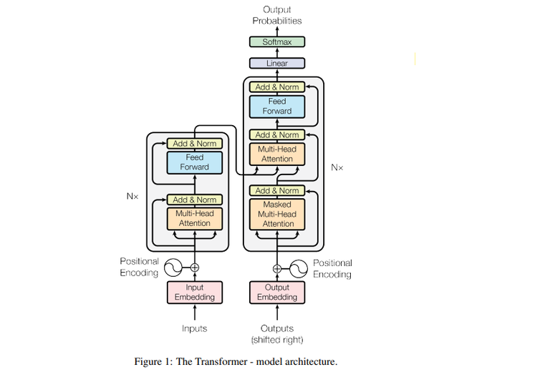

Encoder: The encoder consists of a stack of N = 6 identical layers. Every layer comprises two sub-layers. The first component is a multi-head self-attention mechanism, while the second is a straightforward, position-wise fully connected feed-forward network. We utilize a residual connection for each of the two sub-layers, succeeded by layer normalization. The output of each sub-layer is LayerNorm(x + Sublayer(x)), where Sublayer(x) is the function executed by the sub-layer itself. To enable these residual connections, all sub-layers in the model, including the embedding layers, generate outputs with a size of = 512.

Decoder: The multi-head self-attention layer in the decoder differs slightly from that in the encoder. It conceals all tokens to the right of the token for which the representation is being calculated, so ensuring that the decoder can only focus on tokens before the token it aims to forecast. This is illustrated in Figure 1 as "masked multi-head attention." The Decoder incorporated an additional sublayer, which is a multi-head attention layer applied to all outputs of the Encoder.

Attention: An attention function is defined as a mapping of a query and a collection of key-value pairs to an output, with the query, keys, values, and output represented as vectors. The result is calculated as a weighted sum of the values, with the weight for each value determined by a compatibility function between the query and the relevant key.

A. Scaled Dot-Product Attention: We refer to our specific attention mechanism as "Scaled Dot-Product Attention." The input comprises queries and keys of dimension , and values of dimension . We calculate the dot products of the attention layers operating concurrently.

Execute a query utilizing all keys, divide each by , then apply the softmax function to derive the weights for the data. we simultaneously compute the attention function on a collection of queries organized as a matrix Q. The keys and values are consolidated into matrices K and V. We calculate

The two predominant attention mechanisms are additive attention and dot-product (multiplicative) attention. Dot-product attention is equivalent to our algorithm, with the sole exception of the scaling factor of . Additive attention calculates the compatibility function with a feed-forward network with one hidden layer. Although both exhibit comparable theoretical complexity, dot-product attention is far more efficient in terms of speed and space in practice, as it can be executed using highly improved matrix multiplication algorithms.

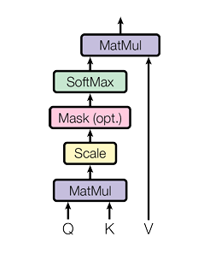Figure 2: Scaled Dot-Product Attention

For small values of dk, both processes exhibit comparable performance; nevertheless, additive attention surpasses dot product attention without scaling for larger dk values. we hypothesize that for substantial values of dk, the dot products increase significantly in magnitude, causing the softmax function to enter regions characterized by exceedingly small gradients. To mitigate this effect, we normalize the dot products by

B. Multi Head Attention: Rather than executing a single attention function utilizing -dimensional keys, values, and queries, we determined it advantageous to linearly project the queries, keys, and values h times using distinct, learnt linear projections to , and dimensions, respectively. We subsequently execute the attention function in parallel on each of these projected versions of queries, keys, and values, resulting in -dimensional output values. The numbers are concatenated and subsequently projected, yielding the final results, as illustrated in Figure 3.[5]

Multi-head attention enables the model to concurrently focus on input from various representation subspaces at distinct places. Averaging impedes this with a solitary attention head.

Where the projection are parameter matrices ,

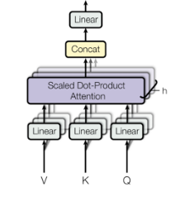 here h is the number of parallel attention layers.

Figure 3: Multi Head Attention

Position-wise Feed Forward Network: Alongside attention sub-layers, every layer in our encoder and decoder incorporates a fully connected feed-forward network, which is applied uniformly and independently to each position. This has two linear transformations interspersed with a ReLU activation function.

Although the linear transformations remain consistent across various places, they employ distinct parameters from layer to layer.

Self-attention: The core mechanism of Transformers is self-attention, enabling the model to efficiently capture relationships between words in a sequence regardless of their distance. Self-attention connects all words in constant time, in contrast to recurrent layers that rely on O(n) sequential processes, hence significantly enhancing parallelization and computational efficiency. Acquiring long-range dependencies—where remote words influence each other—poses a significant challenge in sequence modeling. In recurrent networks, information must traverse many time steps, complicating the models' ability to preserve context across prolonged sequences. Despite necessitating multiple stacked layers and thereby elevating processing complexity, convolutional layers can mitigate this issue. Self-attention minimizes path length and enhances dependency learning through direct connections among all input tokens. Self-attention additionally enhances interpretability. Attention heads, specializing in diverse syntactic and semantic patterns, can highlight important textual linkages. This enables models such as BERT and GPT to excel in tasks including machine translation, summarization, and question-answering. Although extended sequences are computationally expensive, self-attention can enhance efficiency by restricting focus to certain areas. Self-attention is crucial in modern NLP models as it facilitates accelerated training, enhanced long-range dependency acquisition, and improved interpretability.[4]

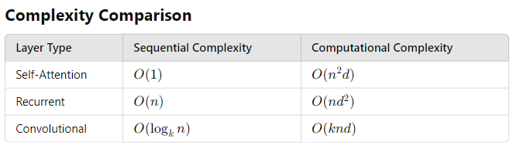

Figure 4: Complexity Comparison of Self-attention, Recurrent and Convolutional models

For long-range dependencies, self-attention shortens the path length to O(1), therefore optimizing deep learning tasks.

**Generative Pre-trained Transformer (GPT)**

1. Definition of GPT: The GPT model generates vast amounts of relevant and intricate machine-generated text from minimal input. GPT models are classified as language models that replicate human text through deep learning approaches, functioning as autoregressive models where the current value depends on preceding values.

a. GPTs are language models pre-trained on vast quantities of textual data and can perform a wide range of language-related tasks.

b. A GPT is a language model relying on DL that can generate human-like texts based on a given text-based input.

c. GPT is a language model developed by OpenAI to help give systems intelligence and is used in such projects as ChatGPT.

2. Evolution of GPT model: Generative artificial intelligence has arisen from significant advancements in natural language processing technology facilitated by GPT models. Before GPT, NLP models relied on extensive annotated data specific to various tasks. The primary limitations of this strategy were that models were constrained by their training datasets and acquiring sufficient labeled data was difficult. Their inability to generalize from training data renders them less adaptable to new challenges.

OpenAI introduced GPT-1, a generative language model trained on unlabeled data, to address these challenges. GPT-1 could be fine-tuned for many tasks, including sentiment analysis, categorization, and question-answering, by producing appropriate responses based on input text, therefore surpassing predefined categories. This transformed NLP as GPT-1 demonstrated the potential of generative models to do various linguistic tasks. Released in 2018, GPT-1 was a pivotal advancement as it enabled computers to generate and comprehend language more naturally. Utilizing an extensive corpus of literature, it had a 12-layer transformer architecture incorporating a self-attention mechanism. Its ability to execute zero-shot tasks, indicating that generative pretraining can be effective with minimal fine-tuning, was one of its most significant achievements.

OpenAI launched GPT-2 in 2019, expanding upon the achievements of GPT-1. This model, with 1.5 billion parameters—tenfold that of GPT-1—demonstrated significant scale improvements. It was designed to handle a wide range of NLP tasks, including translation and summarization, without the necessity for extensive training data. GPT-2 significantly enhanced language prediction by demonstrating an exceptional ability to comprehend long-range relationships inside text. Processing unrefined input text enables the generation of coherent and contextually pertinent text sections, so illustrating the expanding capabilities of generative models.

The subsequent major iteration, GPT-3, provided a groundbreaking advancement in artificial intelligence language processing. With an impressive 175 billion parameters—100 times greater than GPT-2—it is among the largest and most powerful language models ever created. GPT-3, trained on an extensive dataset of 500 billion words, was capable of generating language that nearly resembled human writing. It possessed exceptional abilities in essay composition, addressing complex inquiries, basic arithmetic, and coding. GPT-3 was primarily accessible via a cloud-based API due to its substantial scale and computational demands, enabling developers to integrate it into various projects. Despite its complexity raising concerns around artificial intelligence transparency, its ability to generate very realistic language led to widespread acceptance in both creative and commercial domains.

OpenAI introduced ChatGPT in 2022, building upon GPT-3.5. This version improved upon GPT-3 by refining its ability to generate human-like responses. GPT-3.5 was trained on extensive datasets comprising social media posts, Wikipedia entries, and news articles, utilizing a diverse amalgamation of text and code. In conversational applications, this enhanced its ability to comprehend context and generate more accurate responses. Released in March 2023, GPT-4 is the most sophisticated multimodal language model offered by OpenAI.[2] It features superior reasoning capabilities and an extended context window of up to 32,768 tokens. GPT-4 was trained using reinforcement learning on a combination of public data and licensed datasets to align with human expectations. Providing enhanced precision, greater fluency, and an expanded array of functionalities, it signifies the subsequent stage in the evolution of generative artificial intelligence, building upon prior iterations.

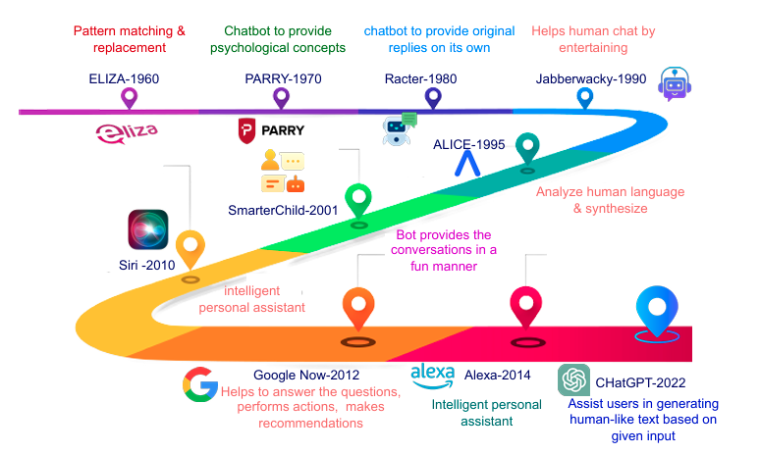

Figure 5: GPT road map

3. GPT and Its Architecture: Generative Pre-trained Transformer (GPT) Pre-trained Transformer models are neural networks designed for natural language processing (NLP) applications, including language modeling, text classification, and text synthesis. The design of GPT is based on the Transformer model, which is ideally suited for NLP applications due to its utilization of self-attention mechanisms to analyze input sequences of varied lengths. GPT simplifies the architecture by utilizing only decoder blocks, in contrast to the traditional Transformer approach that includes both encoder and decoder blocks. Utilizing unsupervised learning techniques, particularly through the prediction of subsequent words in a sequence based on preceding words, it is pre-trained on vast amounts of textual data. This pre-training enables the model to obtain substantial natural language representations that may be tailored for specific tasks.[2]

The input tokens—words or subwords—are converted by the input embedding layer into continuous vector representations that Transformer blocks may process. Positional encoding is incorporated into the input embeddings to convey information regarding the relative positions of tokens, given the Transformer architecture lacks an inherent sense of order. Masking is utilized in certain contexts, such as language modeling, to ensure the model only utilizes tokens preceding the target word.

Transformer blocks constitute the foundation of GPT, as they enable the model to focus on several aspects of the input during processing. The linear and softmax functions are significant in the output phase. The softmax function, frequently utilized in classification tasks, generates a probability distribution across a set of output classes.[3] Linear transformations, employed in the attention mechanism to determine the relevance of each token, generate key, value, and query vectors for every token. These linear functions enhance predictions by modifying the output of the multi-head attention layer and are utilized in the feedforward layers. The last layer predicts the subsequent token in the sequence by linear functions.

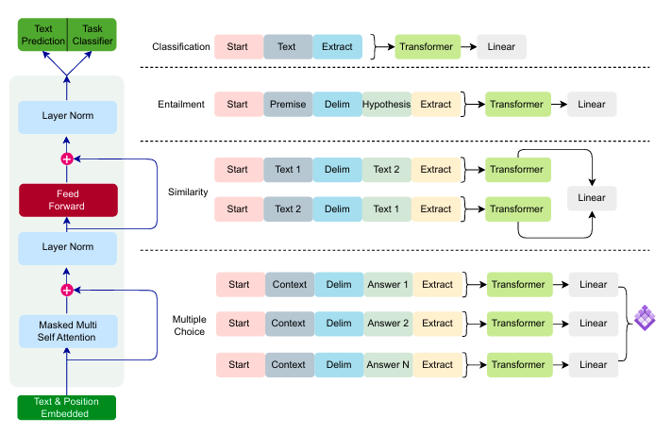

Figure 6: GPT Model with fine tuning

Pre-training, wherein the model is trained on a substantial dataset in an unsupervised manner before to fine-tuning for specific tasks like as text categorization or text generation, is a crucial element of GPT.[2] Fine-tuning modifies the pre-trained model through supplementary training on task-specific data, hence enhancing its performance for new tasks or datasets.

Language modeling, which involves predicting the subsequent word in a sequence based on preceding ones, underpins GPT's functionality. This enables the model to learn associations between words, thereby capturing their meanings and contextual dependencies from the training data. GPT is an excellent instrument for various NLP applications, as its ability to learn patterns enables it to provide coherent and contextually relevant information.

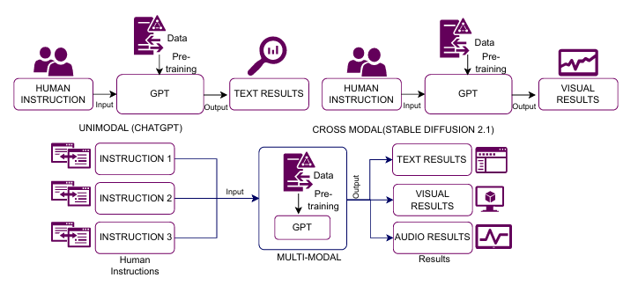

Figure 7: Comparision between Unimodal, crossmodal and multimodal GPT

**Impact on different fields**

1. Education and Research: ChatGPT has significantly transformed education and research by increasing knowledge accessibility, automating academic tasks, and hence improving learning. For researchers, educators, and students, its ability to process vast amounts of data and provide human-like responses is a significant benefit.

The ability of ChatGPT to provide personalized learning experiences is one of its most significant advantages for classroom application. ChatGPT offers students prompt explanations, summaries, and methodical solutions for challenging subjects, functioning as a virtual tutor. This flexibility enables students to learn at their own pace and attain a deeper understanding of subjects without the constraints of traditional classroom attendance. ChatGPT may generate flashcards, quizzes, and practice questions tailored to specific learning needs, hence enhancing information retention. ChatGPT is an excellent resource for educators, facilitating the automation of routine tasks such as content creation, lesson planning, and assessment grading. It enables educators to create interactive exercises, formulate assignments, and develop artificial intelligence-driven chatbots for classroom engagement. Minimizing administrative burdens enables educators to focus more on student engagement, curriculum development, and innovative teaching methodologies.

ChatGPT assists in academic writing and literature reviews by synthesizing research papers, identifying key concepts, and suggesting potential avenues for further research. Its functionalities enable researchers to swiftly analyze extensive datasets, discern patterns, and generate structured reports. ChatGPT assists with abstracts, introductions, and conclusions, so maximizing and conserving time in academic writing. Proofreading and linguistic assistance represent other essential applications of ChatGPT in the educational setting. Many students and scholars find it challenging to organize their essays, theses, or research papers. ChatGPT can enhance writing clarity, grammatical precision, and sentence structure. Translating books, elucidating complex concepts, and improving linguistic proficiency render academic writing more accessible to a global audience, significantly benefiting non-native English speakers. Additionally, ChatGPT contributes to the cultivation of critical thinking and innovation. While it provides rapid information, it also presents multiple perspectives on a topic, so facilitating scholarly and student engagement in critical discourse. As a collaborator in brainstorming, it can generate concepts for artistic endeavors, thesis topics, and research proposals, thereby fostering intellectual curiosity and innovation.

ChatGPT raises ethical and reliability concerns in research and education notwithstanding its advantages. Institutions must address issues such as plagiarism, misinformation, and excessive reliance on AI-generated content. Colleges and educators should implement procedures that prioritize fact-checking and human oversight in academic work to ensure the ethical usage of AI. Moreover, due to the potential for artificial intelligence algorithms to generate inaccurate or biased responses, students and researchers must critically evaluate the provided information.

2. Health-care: Patient data privacy is a critical issue, requiring rigorous security measures to ensure confidentiality and compliance with medical legislation like HIPAA and GDPR. The primary application of ChatGPT in the healthcare sector is the provision of immediate medical information. ChatGPT enables people to pose general health inquiries, understand symptoms, and receive guidance on prevalent illnesses. While it does not replace expert medical advice, it provides information on sickness prevention, medication usage, and lifestyle recommendations, serving as an initial resource for health education. ChatGPT assists medical professionals with clinical decision support by consolidating patient cases, analyzing medical literature, and suggesting potential diagnoses based on symptoms. Rapid access to relevant studies and treatment guidelines enables nurses and physicians to stay abreast of the latest medical research. ChatGPT can assist medical personnel in generating electronic health records, discharge summaries, and medical reports, thereby reducing their documentation burden. ChatGPT enhances virtual consultations in telemedicine by serving as an AI-driven assistant, hence facilitating more effective interactions between doctors and patients. Prior to a medical appointment, it can arrange appointments, prioritize patient inquiries, and provide first evaluations. This enhances healthcare accessibility, especially for individuals residing in remote areas with limited access to medical services. ChatGPT's ability to analyze extensive data, condense study findings, and assist in hypothesis generation benefits medical research. Researchers can leverage insights from scientific literature to predict health risks, analyze disease breakout trends, and facilitate drug discovery. It can also facilitate systematic reviews, funding applications, and research paper authorship, so enhancing the research process. ChatGPT's impact on mental health support is yet another significant aspect. AI-powered chatbots can provide emotional support, regulate stress and anxiety, and offer self-care guidance. While not a replacement for therapy, ChatGPT can be integrated into mental health applications to offer immediate guidance and guide users to professional assistance when necessary. While ChatGPT offers benefits, its application in healthcare raises ethical and reliability concerns. Erroneous or deceptive medical information can have significant consequences; therefore, content generated by artificial intelligence must be evaluated by medical professionals. A significant worry is patient data privacy, necessitating stringent security procedures that ensure anonymity and compliance with HIPAA and GDPR.

3. Industry: ChatGPT is transforming industries by enhancing automation, streamlining processes, and refining decision-making. AI-powered chatbots in customer service respond to inquiries, reduce wait times, and personalize user interactions. Medical recordkeeping, patient engagement, and AI-assisted diagnosis contribute to healthcare improvement. The finance industry use ChatGPT for customized banking solutions, risk assessment, and fraud detection. Predictive maintenance, quality assurance, and supply chain optimization all enhance artificial intelligence in manufacturing. Content creation and marketing employ artificial intelligence to provide customer insights, SEO content, and advertisements. Academic assistance and AI-enhanced learning instruments enhance both research and instruction. Artificial intelligence is utilized in the legal and human resources sectors for automating recruitment, conducting compliance assessments, and analyzing documents. To ensure the ethical deployment of artificial intelligence, challenges such as data security, bias, and misinformation must be addressed. ChatGPT's function will evolve as enterprises use artificial intelligence (AI), hence enhancing efficiency, inventiveness, and accessibility across many business sectors.

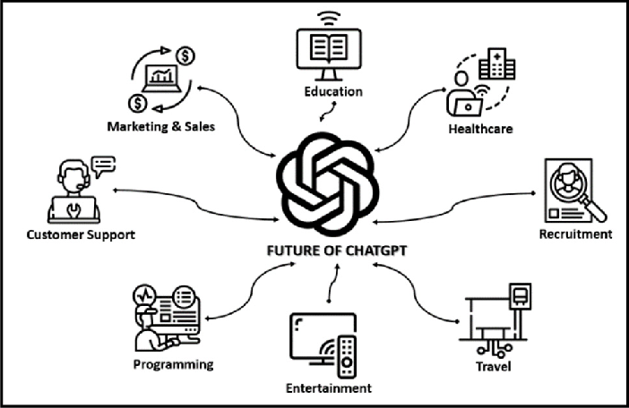

Figure 8: Applications of Chatgpt

**Conclusion**

GPT and other large language models significantly alter our relationships with technology and each other. These models advance various fields through customized guidance, client support, language translation, and content generation. Benchmark translation problems demonstrate that transformer-based architectures, such as GPT, offer significant efficiency improvements compared to traditional recurrent and convolutional networks in translation tasks. However, as these technologies advance, ethical and social concerns like as biases in training data, privacy safeguards, and their impact on human creativity and employment must also be considered. Optimizing the benefits of these models necessitates meticulous and contemplative application that mitigates potential risks. The ethical implementation and ongoing evaluation will enable us to maximize the potential of GPT and similar models, fostering a more inclusive, efficient, and innovative digital future.

**References**

1. Khurana, D., Koli, A., Khatter, K., & Singh, S. (2022). Natural language processing: State of the art, current trends, and challenges. Springer Nature.

2. Yenduri, G., Ramalingam, M., Selvi, G. C., Supriya, Y., Srivastava, G., Maddikunta, P. K. R., Raj, G. D., Jhaveri, R. H., B., P., Wang, W., Vasilakos, A. V., & Gadekallu, T. R. (2023). GPT (Generative Pre-trained Transformer)– A comprehensive review on enabling technologies, potential applications, emerging challenges, and future directions. arXiv preprint arXiv:2305.10435v2. <https://doi.org/10.48550/arXiv.2305.10435>

3. “Introducing OpenAI”. [Accessed on 01.02.2025]. [Online]. Available: https://openai.com/blog/introducing-openai

4. Amatriain, X., Sankaran, A., Bing, J., Bodigutla, P. K., Hazen, T. J., & Kazim, M. (n.d.). Transformer models: An introduction and catalog.

5. Vaswani, A., Jones, L., Shazeer, N., Gomez, A. N., Parmar, N., Uszkoreit, J., Kaiser, Ł., & Polosukhin, I. (2017). Attention is all you need. Proceedings of NeurIPS 2017. <https://doi.org/10.48550/arXiv.1706.03762>

6. Sutskever, I., Vinyals, O., & Le, Q. V. (2014). Sequence to sequence learning with neural networks. arXiv. https://arxiv.org/abs/1409.3215v3

7. Schmidt, R. M. (2019). Recurrent neural networks (RNNs): A gentle introduction and overview. arXiv. https://arxiv.org/abs/1912.05911v1